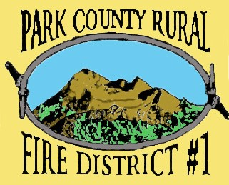
“Dedicated to Serving with Integrity, Leadership, and Compassion.”
It is the Mission of Park County Rural Fire District #1 to protect life and prevent loss to property within the District. We will accomplish this Mission in an economical and professional manner, through high quality emergency response and progressive training and education, and will strive to create alliances with our community and other emergency agencies.

PARK COUNTY RURAL FIRE DISTRICT #1
REGULAR BOARD MEETING AGENDA May 20, 2024
TIME: 6:00 P.M.
LOCATION: 304 EAST PARK STREET LIVINGSTON, MT
❖ CALL MEETING TO ORDER
❖ PUBLIC COMMENT—
❖ APPROVE MINUTES FROM April 8 and May 6 MEETINGS (Ref 1)
❖ REVIEW CLAIMS AND WARRANTS
❖ FINANCIAL REPORT MARCH (Ref 2)
❖ FIRE CHIEFS REPORT FOR APRIL (Ref 3)
❖ OLD BUSINESS
DISCUSSION/DECISION AND UPDATE ON THE WEBSITE
DISCUSSION/DECISION ON BYLAWS AND CODE OF CONDUCT (Ref 4)
DISCUSSION/DECISION ON UPDATING AND APPROVING SOP/SOG
❖ NEW BUSINESS
DISCUSSION/DECISION ON THE PRELIMINARY FY25 BUDGET (Ref 5)
PUBLIC COMMENT
❖ ADJOURNMENT

